Merging User Direct

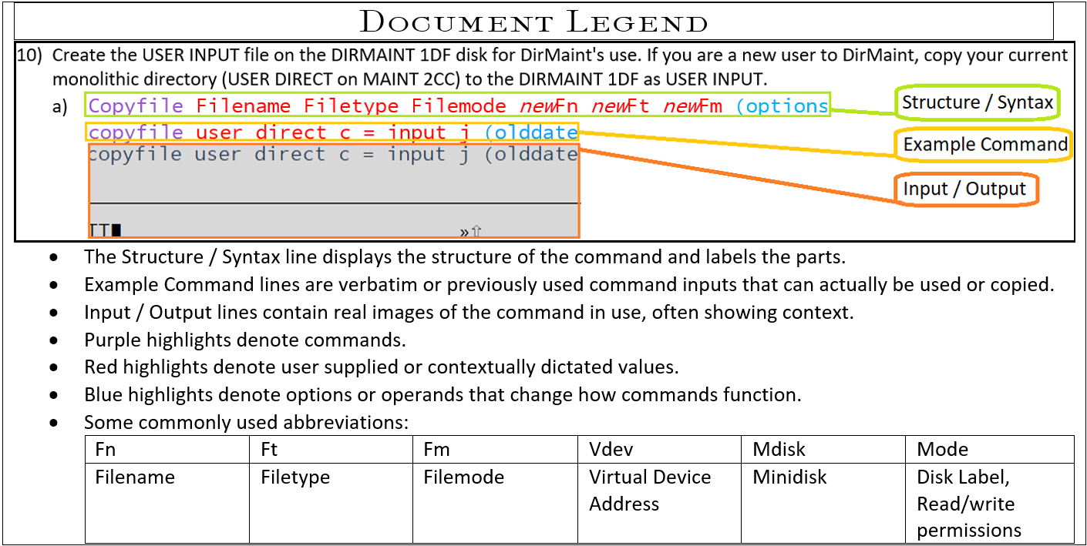

* Source System will refer to the, “old” in the case of upgrades.
* Target System will refer to the, “new” system.

1. Pull down a User Withpass from the Target and Source systems. When receiving the file name them; Source and Target respectively with the filetype Direct.  
   ex. Source system:
   1. DIRM operand  
      DIRM user withpass  
      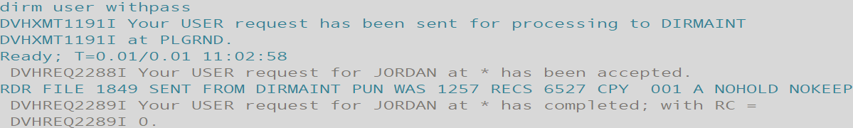
   2. Receive fileid filename filetype filemode (options  
      Receive 1849 target direct a   
      
      1. User Direct is located on PMAINT 2CC if you’d like to manually grab the file.
2. Merge the source and target system’s user directories into a single composite directory on the source system using; **DRCTLIST****,** **DRCTPRUN**and **DRCTCOMP** as instructed below:
   1. Verify REXX exec “**DRCTLIST** EXEC A” uses proper inputs for SOURCEIN and TARGETIN file names and execute to create, “MIGRATE USERLIST A”.  
      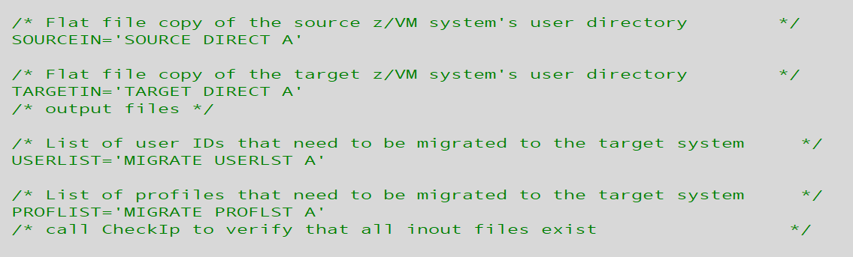
   2. Execute DRCTLIST to list user names
      1. **DRCTLIST**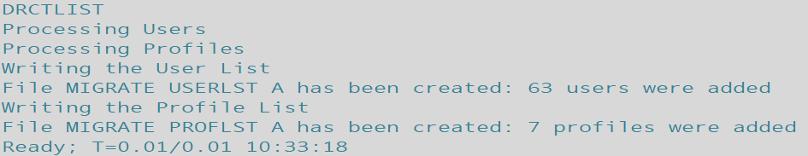
   3. Execute REXX exec “**DRCTPRUN**” to ‘prune’ ”MIGRATE USERLIST A” list into “MIG$NEW USERLST A”.
      1. **DRCTPRUN**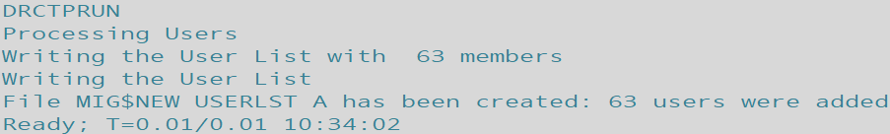
   4. Edit “MIG$NEW USERLST A” – verify expected user entries appear; watch for $SYSTEM$ entry – has been a list of z/VM system volumes. Remove release-specific users such as:

6VMDIR10

6VMPTK10

6VMRAC10

6VMRSC10

6VMTCP10

(Also MAINT620 and any duplicates from USER/IDENTITY matchup).

* 1. Execute REXX exec “**DRCTCOMP**” – verify proper inputs used.
     1. **DRCTCOMP**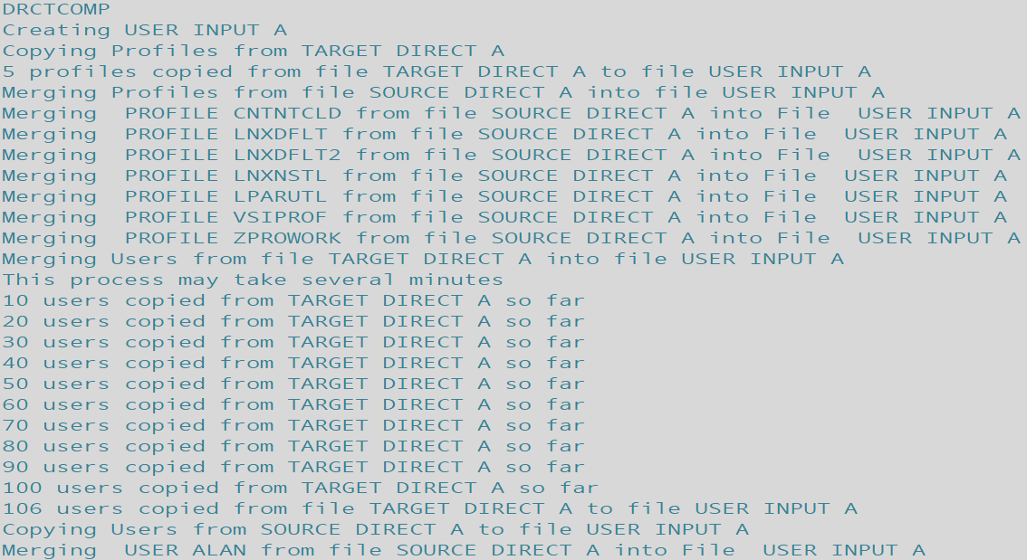  
        (continues for all the users not present on both systems.)  
        

1. Open USERINPUTA in XEDIT and check the banner comment at the top for the version. Verify correct entry types while watching for duplicate ‘USER’ & ‘IDENTITY’ definitions.
   1. Xedit filename filetype filemode  
      X user input a  
      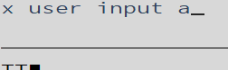

Consult the DIRM Batch Update instructions to apply a monolithic directory placing it in production.

DRCTLIST

/* DRCTLIST - create lists of unique users and profiles that need to */

/* be migrated to the system directory on the target system */

/* Runs on the target system */

/* input files */

/* Flat file copy of the source z/VM system's user directory */

SOURCEIN='SOURCE DIRECT A'

/* Flat file copy of the target z/VM system's user directory */

TARGETIN='TARGET DIRECT A'

/* output files */

/* List of user IDs that need to be migrated to the target system */

USERLIST='MIGRATE USERLST A'

/* List of profiles that need to be migrated to the target system */

PROFLIST='MIGRATE PROFLST A'

/* call CheckIp to verify that all inout files exist */

Call CheckIp

/* erase the output files if they exist */

ADDRESS COMMAND 'ESTATE 'USERLIST

If RC = 0 then 'Erase 'USERLIST

ADDRESS COMMAND 'ESTATE 'PROFLIST

If RC = 0 then 'Erase 'PROFLIST

Say 'Processing Users'

/* extract user names from new z/VM system's directory */

'pipe < 'TARGETIN' | locate 1-9 /USER /',

'| specs word 2 1 | sort | stem NUSERLST.'

/* extract user names from source z/VM system's directory */  
'pipe < 'SOURCEIN' | locate 1-9 /USER /',

'| specs word 2 1 | sort | stem PUSERLST.'

Say 'Processing Profiles '

/* extract profile names from target z/VM system's directory */

'pipe < 'TARGETIN' | locate 1-11 /PROFILE / | nlocate 1 /*/',

'| specs word 2 1 | sort | stem NPROFLST.'

/* extract profile names from source z/VM system's directory */

'pipe < 'SOURCEIN' | locate 1-11 /PROFILE / | nlocate 1 /*/',

'| specs word 2 1 | sort | stem PPROFLST.'

Say 'Writing the User List'

addctr=0

found=0

/* extract unique user IDs from the source z/VM system */

Do m = 1 to PUSERLST.0

Do x = 1 to NUSERLST.0

If NUSERLST.x =PUSERLST.m then found=1

End

If found=0 then Do

addctr=addctr+1

adduser.addctr=PUSERLST.m

End

found=0

End

/* write the list of unique user IDs from the source z/VM */  
/* system to the output file */

adduser.0=addctr

'pipe stem adduser. | >> 'USERLIST

Say "File "USERLIST" has been created: "adduser.0" users were added"

profctr=0

found=0

/* extract unique profile IDs from the source z/VM system */

Do m = 1 to PPROFLST.0

Do x = 1 to NPROFLST.0

If NPROFLST.x =PPROFLST.m then found=1

End

If found=0 then Do

profctr=profctr+1

addprof.profctr=PPROFLST.m

End

found=0

End

/* write the list of unique profiles from the source z/VM */

/* system to the output file */

Say 'Writing the Profile List'

addprof.0=profctr

'pipe stem addprof. | >> 'PROFLIST

Say "File "PROFLIST" has been created: "addprof.0" profiles were added"

Exit

CheckIp:

/* check for the input files - exit with RC 04 if not found */

IFiles.1=SOURCEIN

IFiles.2=TARGETIN

IFiles.0=2

Do C=1 to IFiles.0

ADDRESS COMMAND 'ESTATE 'IFiles.C

If RC <> 0 then Do

Say 'Input file 'IFiles.C' not found - terminating'

Exit 4

End

End

Return

DRCTPRUN

/* DRCTPRUN - 'prune' list of user entries from MIGRATE USERLST A */

/* that should not move to new system */

/* Runs on the target system. MAINT620 */

/* input files */

/* Flat file from EXEC DRCTLIST EXEC - to be replaced */

SOURCEIN='MIGRATE USERLST A'

/* output file */

/* List of user IDs that need to be migrated to the target system */

USEROUT='MIG$NEW USERLST A'

/* build list of user names NOT to migrate to new system */

Call Excld_Lst

/* call CheckIp to verify that all inout files exist */

Call CheckIp

/* erase the output files if they exist */

ADDRESS COMMAND 'ESTATE 'USEROUT

If RC = 0 then 'Erase 'USEROUT

Say 'Processing Users'

/* get list of unique user names from system directory */

'pipe < 'SOURCEIN' | specs word 1 1 | sort | stem NUSERLST.'

Say "Writing the User List with " NUSERLST.0" members"

Say 'Writing the User List'

addctr=0

found=0

/* match derived users to drop-list and remove matching */

Do m = 1 to NUSERLST.0

Do x = 1 to DROPUSR.0

If NUSERLST.m =DROPUSR.x then found=1  
 End

If found=0 then Do

addctr=addctr+1

adduser.addctr=NUSERLST.m

End

found=0

End

/* write the list of unique user IDs from the source z/VM */

/* system to the output file */

adduser.0=addctr

'pipe stem adduser. | >> 'USEROUT

Say "File "USEROUT" has been created: "adduser.0" users were added"

Exit

CheckIp:

/* check for the input files - exit with RC 04 if not found */

IFiles.1=SOURCEIN

IFiles.0=1

Do C=1 to IFiles.0

ADDRESS COMMAND 'ESTATE 'IFiles.C

If RC <> 0 then Do

Say 'Input file 'IFiles.C' not found - terminating'

Exit 4

End

End

Return

Excld_Lst:

/* build list of user names NOT to migrate to new system */  
xi=0;

xi=xi+1; DROPUSR.xi ='VSMSERVE';

xi=xi+1; DROPUSR.xi ='GCSXA';

xi=xi+1; DROPUSR.xi ='5VMHCD40';

xi=xi+1; DROPUSR.xi ='TFTPD';

xi=xi+1; DROPUSR.xi ='NAMESRV';

xi=xi+1; DROPUSR.xi ='X25IPI';

xi=xi+1; DROPUSR.xi ='NDBPMGR';

xi=xi+1; DROPUSR.xi ='NDBSRV01';

xi=xi+1; DROPUSR.xi ='SNALNKA';

xi=xi+1; DROPUSR.xi ='VMKERB';

xi=xi+1; DROPUSR.xi ='ADMSERV';

xi=xi+1; DROPUSR.xi ='SSLSERV';

xi=xi+1; DROPUSR.xi ='AUDITOR';

xi=xi+1; DROPUSR.xi ='AUTOLOG1';

xi=xi+1; DROPUSR.xi ='AUTOLOG2';

xi=xi+1; DROPUSR.xi ='AVSVM';

xi=xi+1; DROPUSR.xi ='CBDIODSP';

xi=xi+1; DROPUSR.xi ='CMSBATCH';

xi=xi+1; DROPUSR.xi ='DHCPD';

xi=xi+1; DROPUSR.xi ='DISKACNT';

xi=xi+1; DROPUSR.xi ='DTCVSW1';

xi=xi+1; DROPUSR.xi ='DTCVSW2';

xi=xi+1; DROPUSR.xi ='EREP';

xi=xi+1; DROPUSR.xi ='FTPSERVE';

xi=xi+1; DROPUSR.xi ='GCS';

xi=xi+1; DROPUSR.xi ='GSKADMIN';

xi=xi+1; DROPUSR.xi ='IMAP';

xi=xi+1; DROPUSR.xi ='IMAPAUTH';

xi=xi+1; DROPUSR.xi ='LDAPSRV';

xi=xi+1; DROPUSR.xi ='LGLOPR';

xi=xi+1; DROPUSR.xi ='LPSERVE';

xi=xi+1; DROPUSR.xi ='MAINT';

xi=xi+1; DROPUSR.xi ='MIGMAINT';  
xi=xi+1; DROPUSR.xi ='MIGMAINT';

xi=xi+1; DROPUSR.xi ='MONWRITE';

xi=xi+1; DROPUSR.xi ='MPROUTE';

xi=xi+1; DROPUSR.xi ='OPERATNS';

xi=xi+1; DROPUSR.xi ='OPERATOR';

xi=xi+1; DROPUSR.xi ='OPERSYMP';

xi=xi+1; DROPUSR.xi ='OP1';

xi=xi+1; DROPUSR.xi ='OSADMIN1';

xi=xi+1; DROPUSR.xi ='OSADMIN2';

xi=xi+1; DROPUSR.xi ='OSADMIN3';

xi=xi+1; DROPUSR.xi ='OSAMAINT';

xi=xi+1; DROPUSR.xi ='OSASF';

xi=xi+1; DROPUSR.xi ='PERFSVM';

xi=xi+1; DROPUSR.xi ='PORTMAP';

xi=xi+1; DROPUSR.xi ='RACFSMF';

xi=xi+1; DROPUSR.xi ='RACFVM';

xi=xi+1; DROPUSR.xi ='RACMAINT';

xi=xi+1; DROPUSR.xi ='REXECD';

xi=xi+1; DROPUSR.xi ='RSCS';

xi=xi+1; DROPUSR.xi ='RSCSAUTH';

xi=xi+1; DROPUSR.xi ='RSCSDNS';

xi=xi+1; DROPUSR.xi ='RXAGENT1';

xi=xi+1; DROPUSR.xi ='SMTP';

xi=xi+1; DROPUSR.xi ='SNMPD';

xi=xi+1; DROPUSR.xi ='SNMPQE';

xi=xi+1; DROPUSR.xi ='SNMPSUBA';

xi=xi+1; DROPUSR.xi ='SYSDUMP1';

xi=xi+1; DROPUSR.xi ='SYSMON';

xi=xi+1; DROPUSR.xi ='TCPIP';

xi=xi+1; DROPUSR.xi ='TCPMAINT';

xi=xi+1; DROPUSR.xi ='TSAFVM';

xi=xi+1; DROPUSR.xi ='UFTD';

xi=xi+1; DROPUSR.xi ='VMNFS';

xi=xi+1; DROPUSR.xi ='VMRMADMN';

xi=xi+1; DROPUSR.xi ='VMRMSVM';

xi=xi+1; DROPUSR.xi ='VMSERVR';  
xi=xi+1; DROPUSR.xi ='VMSERVS';

xi=xi+1; DROPUSR.xi ='VMSERVU';

xi=xi+1; DROPUSR.xi ='VMUTIL';

xi=xi+1; DROPUSR.xi ='VSMPROXY';

xi=xi+1; DROPUSR.xi ='VSMREQIN';

xi=xi+1; DROPUSR.xi ='VSMREQIU';

xi=xi+1; DROPUSR.xi ='VSMWORK1';

xi=xi+1; DROPUSR.xi ='VSMWORK2';

xi=xi+1; DROPUSR.xi ='VSMWORK3';

xi=xi+1; DROPUSR.xi ='XCHANGE';

xi=xi+1; DROPUSR.xi ='ZVMMAPLX';

xi=xi+1; DROPUSR.xi ='6VMDIR10';

xi=xi+1; DROPUSR.xi ='6VMPTK10';

xi=xi+1; DROPUSR.xi ='6VMRAC10';

xi=xi+1; DROPUSR.xi ='6VMRSC10';

xi=xi+1; DROPUSR.xi ='6VMTCP10';

xi=xi+1; DROPUSR.xi ='610RES';

DROPUSR.0 =xi ;

Return

DRCTCOMP

/* DRCTCOMP - Create USER DIRECT file to be used to migrate user */

/* and profile directory entries from source z/VM system */

/* to the target z/VM system using DIRECTXA */

/* Change Log */

/* */

/* 12/11/12 Modified GETUSER procedure: */

/* Changed: Do until W1='USER' */

/* To: Do until W1='USER' | W1='IDENTITY' */

/* 11/21/13 Modified userlist for Alan's new file */

/* */

/* Runs on the target system */

/* input files */

/* List of profile entries to be migrated - created by exec DIRLIST */

PROFLIST='MIGRATE PROFLST A'

/* List of user entries to be migrated - created by exec DIRLIST */

USERLIST='MIG$NEW USERLST A'

/* Flat file copy of the source z/VM system's user directory */

SOURCEIN='SOURCE DIRECT A'

/* Flat file copy of the target z/VM system's user directory */

TARGETIN='TARGET DIRECT A'

/* output file - USER INPUT A - becomes input to DIRECTXA or DVHBEGIN */

USERDIR='USER INPUT A'

/* call CheckIp to verify that all inout files exist */

Call CheckIp

/* erase the output file if it exists */

ADDRESS COMMAND 'ESTATE 'USERDIR  
If RC = 0 then 'ERASE 'USERDIR

/* create a new output file - must have RECFM F */

Say 'Creating 'USERDIR

'EXECIO 1 DISKW 'USERDIR' 0 F 80 (STRING *'

/* Get the DIRECTORY and GLOBALDEFS entries */

'pipe < ' TARGETIN,

'| specs 1-72 1',

'| pad 80',

'| block 80 fixed',

'| strtolabel /PROFILE/',

'| >> ' USERDIR

/* Copy profiles from flat file copy of the target z/VM system's user */

/* directory file to output file */

Say 'Copying Profiles from 'TARGETIN

Call GetProfs

/* Copy profiles to the output file using the GetDir procedure */

/* Note: profiles must be copied first to insure they are present */

/* when the user entries are processed */

'pipe < 'PROFLIST' | stem PROFS.'

Say 'Merging Profiles from file 'SOURCEIN' into file 'USERDIR

Do P = 1 to PROFS.0

NAME=PROFS.P

Call GetDir

End

/* Copy profiles from flat file copy of the target z/VM system's user */  
/* directory file to output file */

Say 'Merging Users from file 'TARGETIN' into file 'USERDIR

Say 'This process may take several minutes'

Call GetUsers

/* Copy user entries to the output file using the GetDir procedure */

'pipe < 'USERLIST' | stem USERS.'

Say 'Copying Users from 'SOURCEIN' to file 'USERDIR

Do U = 1 to USERS.0

NAME=USERS.U

Call GetDir

End

Say "File "USERDIR" has been created"

Exit

GetDir:

/* extract USER or PROFILE entries from the DIRM WITHPASS file */

/* and place into the output file */

Linein(SOURCEIN,1,0)

Do Forever

LINE=Linein(SOURCEIN)

Parse var LINE W1 W2 .

If W1='USER' & W2 = NAME | W1='PROFILE' & W2 = NAME then Do

'pipe var LINE | specs 1-72 1 | pad 80',

'| block 80 fixed | >> ' USERDIR

Say "Merging " W1 W2 "from file "SOURCEIN" into File " USERDIR

Do Forever

LINE=Linein(SOURCEIN)  
 'pipe var LINE | specs 1-72 1 | pad 80',

'| block 80 fixed | >> ' USERDIR

Parse var LINE L1 .

If L1 = "*DVHOPT" then Return

End /* copy records loop */

End /* if found loop */

End /* main loop */

Return

GetProfs:

/* Extract PROFILE entries from the Target System DIRM WITHPASS file */

/* and place into the output file */

Prof_Count=0

Save_Count=0

Linein(TAREGTIN,1,0)

Do Until LINES(TARGETIN)=0 | W1='USER'

LINE=Linein(TARGETIN)

Parse var LINE W1 .

If W1='PROFILE' | W1='Profile' then Do

'pipe var LINE | specs 1-72 1 | pad 80',

'| block 80 fixed | >> ' USERDIR

Prof_Count=Prof_Count+1

/*Do Until LINES(TARGETIN)=0 | W1='*DVHOPT' | W1='USER' */

Do Until LINES(TARGETIN)=0 | W1='USER'

LINE=Linein(TARGETIN)

Parse var LINE W1 .

If W1='PROFILE' | W1='Profile' then Prof_Count=Prof_Count+1

If W1 <> 'USER' then 'pipe var LINE | specs 1-72 1 | pad 80',  
 '| block 80 fixed | >> ' USERDIR

If Prof_Count=Save_Count+10 then Do

Say Prof_Count" profiles copied so far from "TARGETIN

Save_Count=Prof_Count

End

End

End /* copy loop */

End /* Main loop */

Say Prof_Count" profiles copied from file "TARGETIN" to file "USERDIR

Return

GetUsers:

/* Extract USER entries from the Target Systems DIRM WITHPASS file */

/* and place into the output file */

User_Count=0

Save_Count=0

Linein(TARGETIN,1,0)

Do until W1='USER'| W1='IDENTITY'

LINE=Linein(TARGETIN)

Parse var LINE W1 .

End

'pipe var LINE | specs 1-72 1 | pad 80',

'| block 80 fixed | >> ' USERDIR

User_Count=User_Count+1

Do Until LINES(TARGETIN)=0  
 LINE=Linein(TARGETIN)

Parse var LINE W1 .

If W1="USER" | W1="IDENTITY" then User_Count=User_Count+1

'pipe var LINE | specs 1-72 1 | pad 80',

'| block 80 fixed | >> ' USERDIR

If User_Count=Save_Count+10 then Do

Say User_Count" users copied from "TARGETIN" so far"

Save_Count=User_Count

End

End

Say User_Count" users copied from file "TARGETIN" to file "USERDIR

Return

CheckIp:

/* check for the input files - exit with RC 04 if not found */

IFiles.1=PROFLIST

IFiles.2=USERLIST

IFiles.3=SOURCEIN

IFiles.4=TARGETIN

IFiles.0=4

Do C=1 to IFiles.0

ADDRESS COMMAND 'ESTATE 'IFiles.C

If RC <> 0 then Do

Say 'Input file 'IFiles.C' not found - terminating'

Exit 4

End

End

Return